**SOFTWARE REQUIREMENTS SPECIFICATION**

**For**

**Online Quiz System**

**Prepared by:-**

Team 18

**1. Introduction**

**1.1 Purpose**

The main objective of this document is to illustrate the requirements of the project Online Quiz system. The document facilitates effective training and onboarding of team members and stakeholders, verifying their knowledge of essential concepts, terminology, and documentation standards. The quizzes act as a quality assurance tool, helping identify potential gaps in understanding, promoting compliance with documentation guidelines, and fostering continuous improvement. Additionally, the system enables efficient and timely assessment, particularly beneficial for remote or distributed teams, ultimately enhancing communication, collaboration, and the successful implementation of software requirements.

**1.2 Document Conventions**

* Entire document should be justified.
* Convention for Main title
* Font face: Arial
* Font style: Bold
* Font Size: 22
* Convention for Sub title
* Font face: Arial
* Font style: Bold
* Font Size: 20
* Convention for body
* Font face: Arial
* Font Size: 14

**1.3 Scope of Development Project**

Online quizzes go beyond academics, finding applications in education for assessments and skill-building. They're crucial in corporate training, compliance, and recruitment. The adaptability of online quiz systems makes them indispensable across education, training, entertainment, and information dissemination.

Can be used anywhere any time so it saves time of going to far away centres to give exams. No manual work required to prepare and store the result information. To establish a situation where students can both learn and analyse their performance at the same time

**1.4 Definitions, Acronyms and Abbreviations**

JAVA -> platform independence

SQL-> Structured query Language

ER-> Entity Relationship

UML -> Unified Modeling Language

IDE-> Integrated Development Environment

SRS-> Software Requirement Specification

* 1. **References**
* Websites
* [**https://www.scribd.com/doc/53951908/srs-on-online-quiz-system**](https://www.scribd.com/doc/53951908/srs-on-online-quiz-system)
* [**https://www.slideshare.net/lunarrain/srs-for-online-examination-system**](https://www.slideshare.net/lunarrain/srs-for-online-examination-system)

**2. Overall Descriptions**

**2.1 Product Perspective**

Use Case Diagram of Online Quiz System

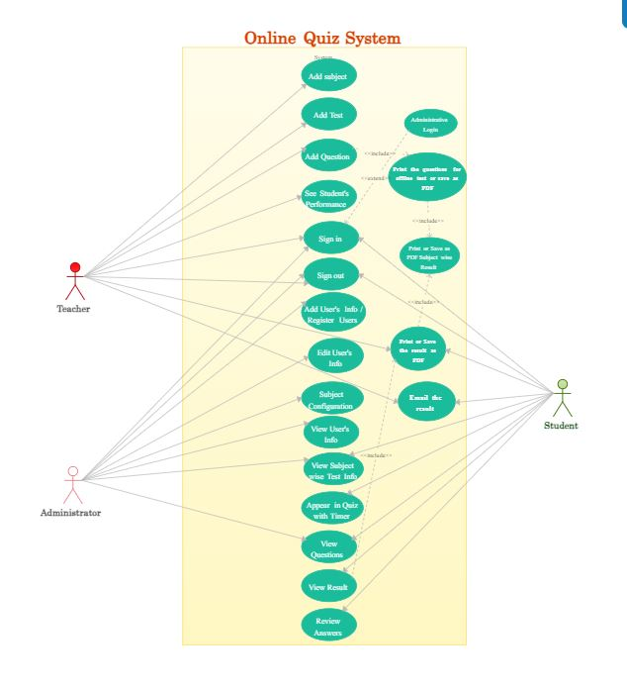

**2.2 Product Function**

Entity Relationship Diagram of online quiz System

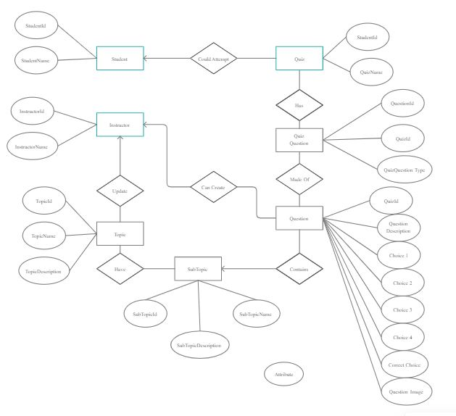

**2.3 User Classes and Characteristics**

Many people can utilize the system, including administrators and students. All users with a working login ID and password should be able to view their personal information, including test scores from past exams, performance graphs, and other data. The only person who should be able to add users or change any type of information in the system is the system administrator.

The features that are available to the Administrator are:

* The administrator has the full fledged rights over the OES.
* Can create/delete an account.
* Can view the accounts.
* Can change the password.
* Insert/delete/edit the information of available on OES.
* Can access all the accounts of the faculty members/students.

The features available to the Students are:

* Can view the different categories of Test available in their account.
* Can view their marks.
* Can view and modify its profile but can modify it to some limited range.

The features available to the Examiner are:

* Can view The different categories of Test conducted by users.
* Can view their marks.
* Can view and modify Results

**2.4 Operating Environment**

Windows will be the operating system used by the product. Furthermore, it will work with Internet Explorer 6.0. The majority of the functions will work with Opera 7.0 or later and Mozilla Firefox. An internet connection is the only prerequisite for using this online product.

**2.5 Assumptions and Dependencies**

The assumptions are:-

* Users are assumed to have consistent and reliable internet connectivity.
* The system expects compatibility with various devices and modern web browsers.
* Secure authentication is assumed for user access, ensuring account integrity.
* Data security measures, such as encryption, are assumed to protect user information.

The dependencies are:-

* Internet infrastructure for user accessibility.
* Robust server infrastructure for hosting and responsiveness.
* Programming language, web framework, and database management system for development.
* Secure authentication services and data security measures.
* Compliance with data protection regulations and dependencies on backup systems.

**2.6 Requirement**

Software Configuration:

Front End:

Language: Java (Java Runtime Environment)

Integrated Development Environment (IDE): NetBeans 7.0.1

Back End:

Database: Microsoft SQL Server

Operating System Compatibility:

Windows 10 or later

MacOS 10.12 or later

Hardware Configuration:

Processor: Modern multi-core processor (minimum Intel Core i-3)

Hard Disk: 256GB or more

RAM: 4GB or more

**2.7 Data Requirement**

The online quiz system requires data storage for user profiles, encrypted passwords, quiz content, and configuration settings. It tracks individual quiz results, user progress, and system logs for monitoring. Access control data manages user roles, while external integrations and metadata contribute to the system's functionality. User preferences, security measures, and backup data ensure a comprehensive and secure data structure, meeting the requirements of a robust online quiz platform.

**3. External Interface Requirement**

**3.1 GUI**

The online quiz system features a user-friendly graphical interface for efficient user and administrator interactions. Key functionalities include:

* Streamlined creation, update, and viewing of quizzes for administrators.
* Quick reports for tracking quiz activities within specific timeframes.
* Efficient stock verification and search capabilities.
* Customizable interface for administrators.
* Integration of all modules into a standardized graphical user interface.
* Interaction with the user management module and a dedicated login/logout section.

Login Interface:-

User registration is simplified, allowing individuals to create an account by entering their details. Subsequent logins require the correct username and password; any errors prompt an immediate message.

Search:-

Efficient searching for quizzes is facilitated for members or administrators by entering quiz types and titles.

Categories View:-

Administrators can easily manage quiz categories, with the ability to add, edit, or delete categories as needed.

Administrator’s Control Panel:-

The control panel empowers administrators by facilitating tasks like adding/removing users, managing quizzes (add, edit, or remove), and controlling quiz options. This structured format ensures a cohesive and standardized graphical interface, contributing to the efficiency of the online quiz system.

**4. System Features**

1. User interaction and experience:

* User registration and authentication.
* Intuitive quiz creation and management interfaces.
* Support for various question types, randomization, and real-time feedback.

1. Scoring and reporting:

* Automated scoring and grading mechanisms.
* User profiles with performance history.
* Timer functionality and comprehensive reporting tools.

1. Security and administration:

* Robust security measures and data privacy compliance.
* Customizable themes and branding options.
* Responsive design, helpdesk support, and integration capabilities.

**5. Other Non-functional Requirements**

**5.1 Performance Requirement**

The performance requirements for an online quiz system are crucial to ensure smooth operation, responsiveness, and reliability. Key performance considerations include:

* Ensure fast response, efficient concurrent user handling, and scalability for growing quiz traffic.
* Prioritize high system reliability, minimizing downtime for uninterrupted user experiences.
* Optimize database performance and minimize network latency for swift data retrieval and transmission.
* Implement security seamlessly, ensuring minimal impact, and establish efficient backup and recovery processes.

**5.2 Safety Requirement**

Implement robust safety measures for the online quiz system, including secure user authentication, encryption of sensitive data, regular system backups, and adherence to data protection regulations.

**5.3 Security Requirement**

* Secure user authentication for access control.
* Encryption of sensitive user data.
* Regular system backups for data integrity.
* Adherence to data protection regulations.

**5.4 Requirement attributes**

* Functional Requirements: Specify quiz creation, user registration, and result generation features.
* Non-functional Requirements: Define performance, security, and scalability criteria.
* Usability and Compatibility: Outline user interface expectations, ease of interaction, and cross-browser/mobile responsiveness.
* Reliability and Security: Address system uptime, data backup, error handling, user authentication, encryption, and regulatory compliance.

**5.5 Business Rules**

In the online quiz system, users register with valid credentials, only authorized administrators create quizzes, and submissions are required before deadlines. Results are accessible post-completion with randomized questions. Secure authentication is mandatory, ensuring data privacy. Administrators have additional privileges, and regular backups maintain system reliability. The system prevents plagiarism, upholding integrity in quiz responses.

**5.6 User Requirement**

* Register with valid credentials for access.
* Participate in quizzes and review results.
* Manage personal profiles, including updates.
* Administrators create and manage quizzes.
* Receive deadline notifications, access secured content, and provide feedback.

**6. Other Requirements**

**6.1 Data and Category Requirement**

The online quiz system requires a robust data structure to store user information, quiz details, and results efficiently. User data includes registration details and performance history, while quiz data encompasses questions, answers, and deadlines. Additionally, implementing a well-defined category system ensures organized quiz classification, facilitating seamless management for administrators. This structured approach to data and categories enhances the system's functionality, providing users with a comprehensive and organized quiz-taking experience.

**6.2 Glossary**

The following are the list of conventions and acronyms used in this document and the project as well:

* Administrator: A designated login ID with privileged access for user administration within the software.
* User: A standard login ID typically assigned to general users interacting with the system.
* Client: Refers to the intended user base for the software.
* SQL: Acronym for Structured Query Language, utilized for retrieving information from a database.
* SQL Server: A server dedicated to storing data in an organized format.
* Layer: Denotes a distinct section or segment within the project structure.
* User Interface Layer: The segment of the assignment corresponding to direct user interaction.
* Application Logic Layer: The project section representing the Web Server, where all computational processes occur.
* Data Storage Layer: The project segment responsible for recording and storing all data.
* Use Case: A high-level diagram illustrating a basic overview of the project's functionalities.
* Class Diagram: A type of static structure diagram depicting the system's classes, their attributes, and relationships.
* Interface: A means of communication facilitating interaction across different mediums.
* Unique Key: A database element utilized to distinguish and uniquely identify entries.

**6.4 Class Diagram**

Essential classes including "User," "Administrator," "Quiz," and "Question," together with their unique characteristics and relationships, are visually outlined in the class diagram for the online quiz system. It gives developers a basic blueprint for creating and implementing a well-organized and effective online quiz system by giving an overview of the data flows and interactions that take place within the system.

